H.T No
Regulations:
A15


Sreenidhi Institute of Science and Technology
(An Autonomous Institution)
Code No: 5A510 Date: 20-Dec-2018 (FN)

B.Tech III-Year I-Semester End External Examination, Nov/Dec - 2018 (Regular)
Power Systems - II (EEE)

Time: 3 Hours Max.Marks:75

Note: a) No additional answer sheets will be provided.
b) All sub-parts of a question must be answered at one place only, otherwise it will not be valued.
c) Missing data can be assumed suitably.

Part - A Max.Marks:25

Answer all QUESTIONS.

1. | Write the importance of power factor in power system. | [3M]
2. | Define the utilization factor and plant use factor. | [3M]
3. | What is meant by neutral grounding? | [3M]
4. | Define the short circuit capacity of a bus. | [3M]
5. | Draw the connection of sequence networks for Double Line to Ground fault through  an impedance z. | [3M]
6. | Write briefly about Ring main distributor. | [2M]
7. | Compare shunt and series capacitors. | [2M]
8. | What are the advantages of sectionalized bus bar? | [2M]
9. | What is secondary distribution system? | [2M]
10. | Define load factor and diversity factor. | [2M]
Part – B Max.Marks:50
ANSWER ANY FIVE QUESTIONS. EACH QUESTION CARRIES 10 MARKS.

11. | a) | Explain the methods of improving power factor. | [5M]
 | b) | Write the importance of voltage control in power system. | [5M]
12. | a) | A power station has maximum demand is 100 MW, the capacity factor is 0.65 and utilization factor is 0.9. Calculate:  i) reserve capacity and  ii) annual energy produced. | [5M]
 | b) | Classify different types of tariff and Explain. | [5M]
13. | a) | Compare in detail about GIS and Air insulated substations. | [5M]
 | b) | Explain briefly about methods of Neutral Grounding. | [5M]
14. | a) | Explain the importance of Per Unit System. | [5M]
 | b) | The reactance of a generator is given as 0.25 pu based on the generators name plate rating of 18 kV, 500 MVA. If the base for calculations is changed to 20 kV, 100 MVA. What is the reactance of generator in p.u. based on new base values? | [5M]
15. | a) | Derive the expressions for voltages and current for a Double Line-to-Ground fault on a power system. | [5M]
 | b) | Draw the positive, negative and zero sequence network of all power system components. | [5M]
16. | a) | What are the general aspect of distribution systems? | [5M]
 | b) | Distinguish between underground cable and overhead line distribution system? | [5M]
17. | a) | Explain with neat sketch operation of On-Load Tap Changing Transformer. | [3M]
 | b) | What is meant by tariff? Explain about block rate and simple tariff. | [4M]
 | c) | Discuss in detail about arcing grounding. | [3M]
18. | a) | A 300 MVA, 20 kV, 3 phase generator has a sub-transient reactance of 15%. The generator supplies two synchronous motors through a 100 km transmission line having transformers at both ends as shown below figure.  In this T1 is a 3 phase transformer with 350 MVA, 20/230 kV, 10% reactance and T2 is made of 3 single phase transformers of rating 100 MVA 127/13.2 kV, 10% reactance. Series reactance of transmission lines line L1 is 0.55 ohm/km, line L2 is 0.44 ohm/km.  Motors: M1: 200 MVA, 13.2 kV, X=20%, M2: 120 MVA, 13.2 kV, X=20%.  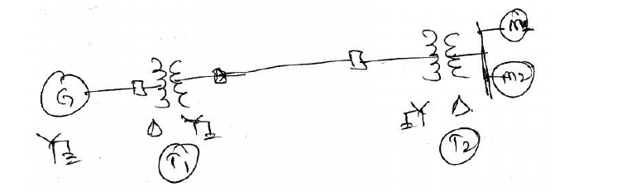 | [4M]
 |  | Draw the reactance diagram with all the reactances marked in p.u. Select the generator rating as base values.
 | b) | What are the symmetrical components of 3 phase system? | [3M]
 | c) | Compare AC and DC Distribution systems? | [3M]

-- 00 -- 00 –

